Atropia v.01
Contents

1) Overview
1.1) High Concept Statement
1.2) Gameplay
1.3) Game World
1.4) Platform
1.5) Target Audience
2) Gameplay and Mechanics
2.1) Camera
2.2) Controls
2.3) Avatar Mode
2.4) Combat
2.5) Buildings
2.6) Looting
2.7) Survivors
2.8) Commander Mode
2.9) The Tower and Portal
2.10) Character Stats (Strength, Dexterity and Intelligence)
2.11) Experience and Leveling Up
2.12) Inventory and Backpack System
3) Characters
3.1) Humans
3.2) Demons
3.3) Appearance/Style
3.4) Animations
4) Game World
4.1) Building Models In The Different Threat Levels
4.2) Sound
4.3) World Building Advertisements (Nuka Cola, T-Shirts BOGO's etc.)
4.4) In Game Companies (Mini-Mart)
4.5) Lootable Building types
5) User Interface
5.1) Avatar HUD
5.2) Commander HUD
5.3) Main Menu
5.4) Saving/Loading
5.5) Pause Menu
5.6) Inventory/Backpack System

1)Overview

1.1 High Concept Statement
Atropia is a 3D single player game for PC that mixes FPS, RTS and RPG elements. A demon portal has opened up over a skyscraper in the city of Atropia spilling out more and more dangerous demons and it is the player's job to close it by any means necessary.

1.2 Gameplay
The gameplay of Atropia is split into two modes: the “Avatar mode” and “Commander mode”. In Avatar mode, the player controls a single person and is tasked with looting gear from buildings, killing demons, rescuing survivors and building a base (figures 1, 3). In Commander mode the player is in an overview of the base they built and the base serves many functions. It acts as a hub for survivors to regroup at; a place to conduct research to upgrade guns, vehicles, and bombs, in addition to providing vision of the map which can allow the player to spot mobs of enemies early and check on demon activity (figure 2). (expand this section)

1.3 Game World
Atropia is a large city which has a large skyscraper in the middle. There are a few parks but otherwise the city is densely populated with buildings. I plan the art style to be somewhat similar to "Minecraft" or "Unturned" with blocky, low poly textures and structures.

1.4 Platform
I plan to make this game available for PC and I want to optimize the game to allow it to run on lower end PCs.

1.5 Target Audience
My target audience is anyone who is on steam for PC and I want to cater my game to lower end PCs to allow the majority of lower end PCs to play the game.
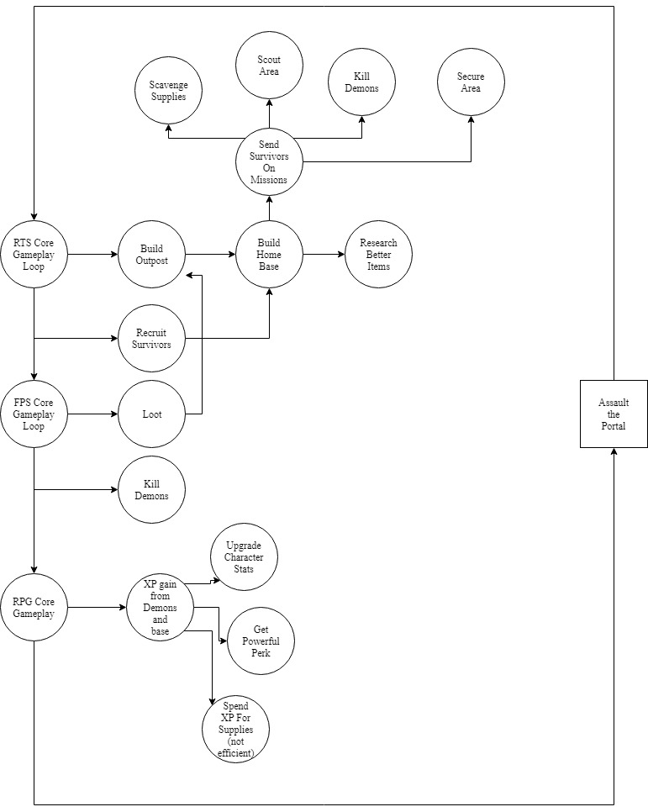
Figure 1 CORE GAMEPLAY LOOP

Figure 2 COMMANDER OVERVIEW
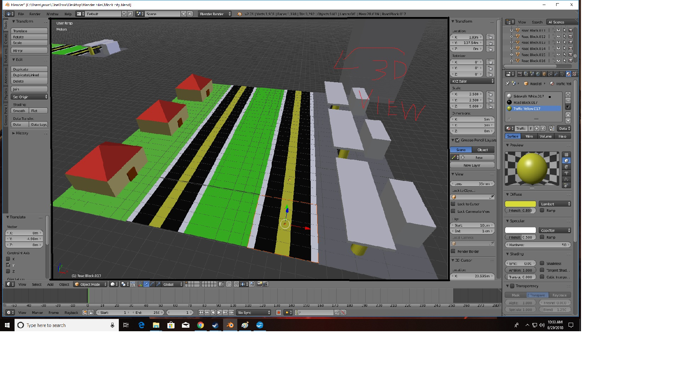
2) Gameplay and Mechanics

2.1 Camera Figure 3 Avatar Camera
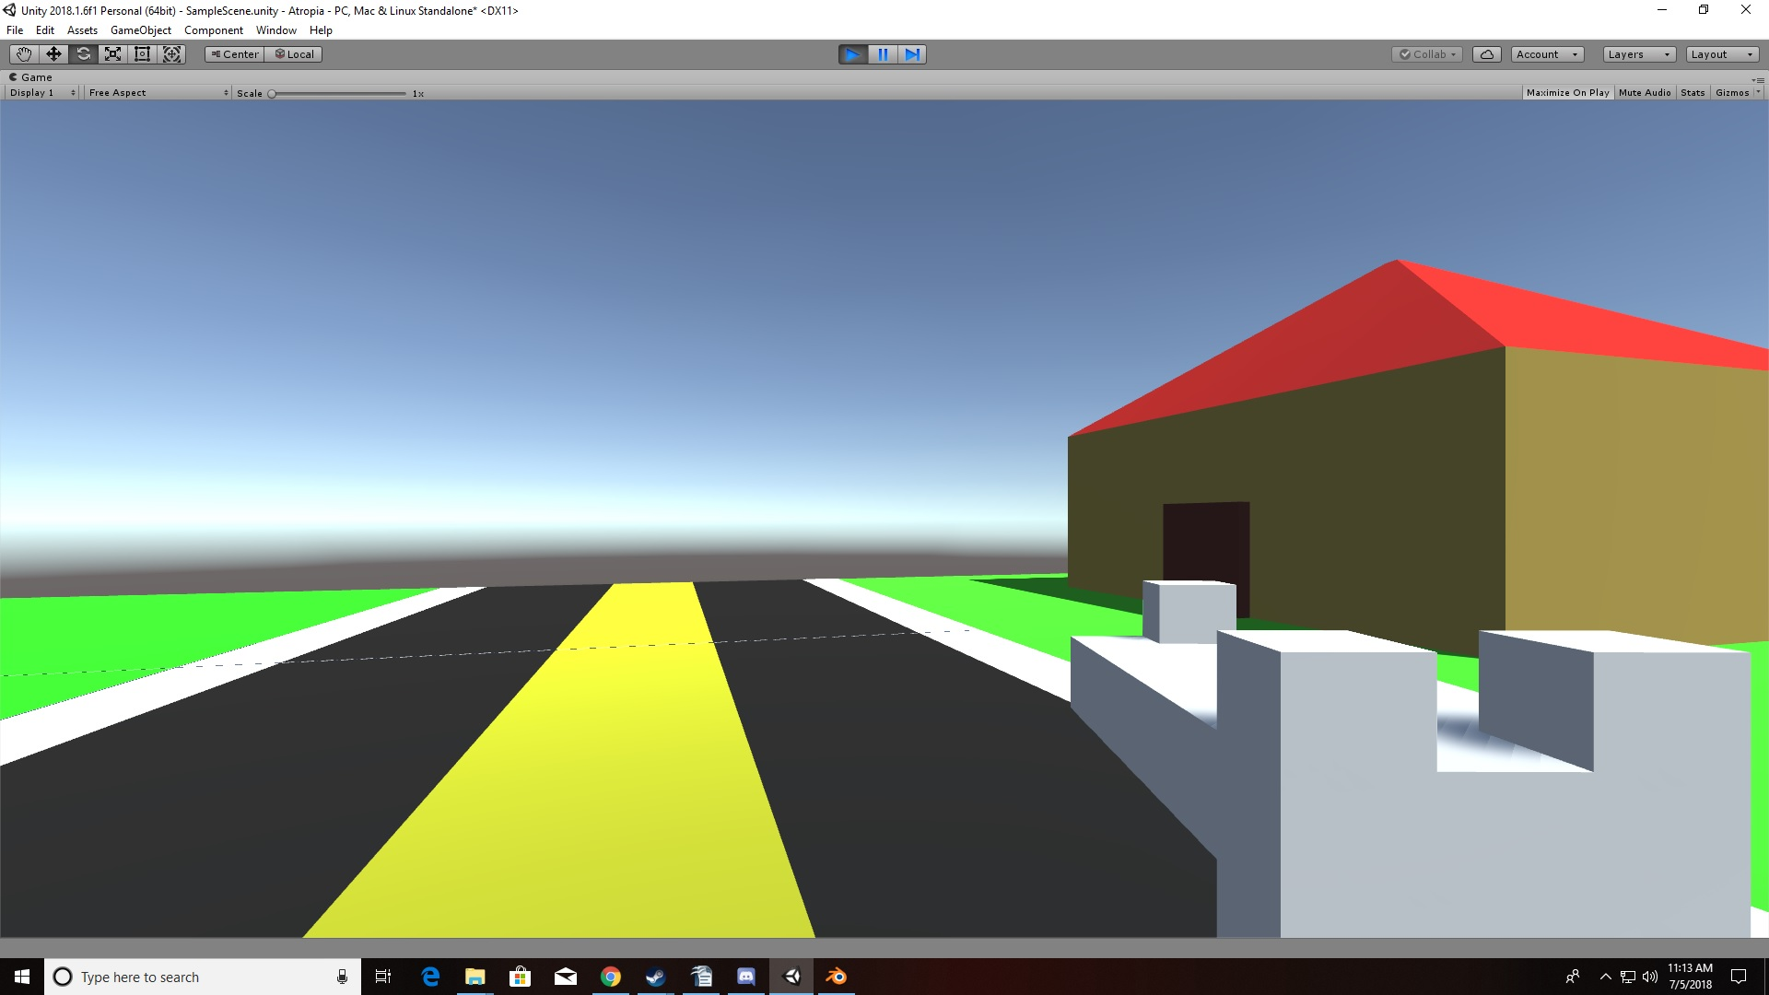
When the player is in the avatar mode their camera will be in first person which allows them to shoot properly and loot as if they were actually in the game. The camera for the commander mode will be an angled top down view of the city as pictured in figure 2.

2.2 Controls
In avatar mode, standard WASD movement with spacebar as a jump. The key I will be used for inventory (backpack) and weapons will be bound to the standard 1-9 number keys.
In commander mode the camera can be moved with mouse panning to the sides of the screen. The camera can zoom in by scrolling up and zoom out by scrolling down. The camera also can rotate left and right with “Q” and “E” respectively. Think XCOM rotation.

2.3 Avatar Mode
The Avatar Mode is the mode that about 70-80% of the gameplay will take place in. This is the first person portion of the game where the players grinds for survival for himself and sets up an outpost/home base. (expand this?)

2.4 Combat
The combat for Atropia is a steady ladder of increasing difficulty that is tied directly to the portal and the player's progress. The game begins initially with slow walking zombies and should end with a massive assault against the portal with survivors and the player slaying behemoths with giant, demonic, flying bugs.
The two core types of combat will be melee and ranged. I want to allow players to make a melee build if they enjoy melee combat by granting bonus melee damage with the strength attribute. Ranged combat will receive buffs from dexterity.
Combat at the beginning of the game should have few enough enemies that the player shouldn't have to build an outpost to hold them off for 15-30 minutes. After 30 minutes the threat level should go up at least one level causing enough enemies to spawn that it should force the player to fortify at least one area to fall back to if they aggravate too many enemies.

2.5 Buildings
Buildings are the main source of loot for the player and also spawn a certain amount of enemies based on the current threat level from the portal. In addition, buildings are the only areas that can be fortified to outposts to hold off the demon hordes. The type of building that is on a chunk is important because when an outpost is built on the building it yields the type of resource that the building is. (create list for buildings)

2.6 Looting
Looting is the only way for survivors to get supplies. The building type will specify what type of loot will be available. Such as snacks and gas to be found at gas stations, and guns at police stations. The player should also be able to select from a list of what specifically they are looking for. The player makes the priority either food, water, guns, or building materials and the intelligence score they have increases the probability of finding an item based on their priority.

2.7 Survivors
Friendly AI survivors can be found at buildings and have a larger chance to spawn the lower the threat level is but will have less gear to assist them. The higher the threat level the lower chance for survivors but they will be better equipped to deal with the horde. The player can enter a dialogue with the survivors telling them to follow them, retreat to the closest outpost, or if no outpost is present the player can build one at the current location, or tell the survivor to wait there while the player finds a suitable location. The survivor will only wait one day then will despawn or will wait until killed.
Survivors are used to man defenses at outposts and can be sent on missions from commander mode. Survivors can also level up like the player and be equipped with better gear from the commander mode based on supplies brought back from looting.

2.8 Commander Mode
Commander mode is the bread and butter of base and survivor management. The player enters commander mode at any outpost at a table that has a map on it. The player then enters a 3D view of Atropia and has real time flying vision of outposts, and survivors scouting areas. Commander mode will have new menus to inspect survivors, equip them and form them into teams of up to 8 survivors. Once survivor groups have been formed, the player can then create a mission for the survivors to complete, such as: kill missions for demon hordes, securing a building for a new outpost, looting, and scouting an area.
Commander mode is important because once outposts are established at certain buildings survivors can also be assigned to new duties including: researching the origin of the demons, food production, ammo production, and defense of the outpost. The output of food, ammo and research is based on how many outposts the player has setup, the types of buildings claimed, and how many survivors are doing collection duty at the outpost. For example, an outpost built on a police station will produce ammunition, and an outpost as a gas station will yield gas that could be used for vehicles or bombs. (expand this section)

2.9 The Tower and Portal
The portal is the main enemy throughout Atropia. The portal and tower must always be visible any time the player is outside to drill home the effect of constant threat. The portal has 7 levels of threat that effect demons that spawn inside the city. The higher the threat level the more dangerous the demons. Threat level is determined by number of outposts and survivors that the player owns, and generates slowly over time, so even if the player built no outposts the portal will progress. At threat level 4 the portal begins to capture buildings that spawns mini portals creating more demons. In addition, the portal starts to close off streets with demonic walls that the player may not move through and can only blow up to create passage.
The tower protects the portal and the immediate surrounding buildings are already captured at the beginning of the game, blocking immediate passage to the tower and portal until the player at least researches bombs. (create threat level table)

2.10 Character Stats
All characters share 3 basic statistics: strength, dexterity and intelligence. Strength gives a bonus to melee damage, and carrying capacity. Dexterity gives a bonus to ranged damage, and running speed. Intelligence gives a bonus to prioritized loot and overall increases rarity of loot.

2.11 Experience and Leveling Up
The player and survivors all gain experience and level up based on killing demons, finding loot, and building outposts. When leveling up, the player and survivors all get a small health point increase as well as a point to put into one of the primary 3 stats.
Available to the player and survivors is one perk slot. Once a perk is picked it can not be removed until a book has been found and read to re-open the perk slot. As base stats are increased more powerful perks can be taken. (create perk chart)

2.12 Inventory and Backpack System
The player stores loot in his inventory which comprises of slots gained from clothing and a backpack. Loot items are one of three sizes: small, medium, or large. Small items fit in a single slot and be something like a water bottle or a pistol. Medium sized objects are like rifles, baseball bats or other backpacks, and take up 5 slots. Large items like car tires, engine parts, or even bodies of demons (for research purposes) take up 10 slots. Backpacks come in the small, medium and large sizes as well and hold 10, 15 and 20 slots respectively.

3) Characters

3.1 Humans
Humans should have a distinct look compared to demons and should be easily identifiable against demons. Humans have tan skin and zombies have green skin for example. (insert art for survivors)

3.2 Demons
Demons come in all shapes and sizes, from small flying skulls, to zombies, to behemoths at the late game.

